Demonstration of CRUD operations and Aggregate functions in MongoDB
ANUGRAHAA V - 2648506
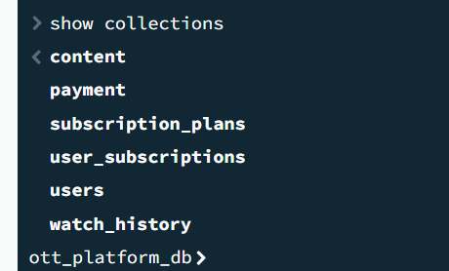
Insert one()
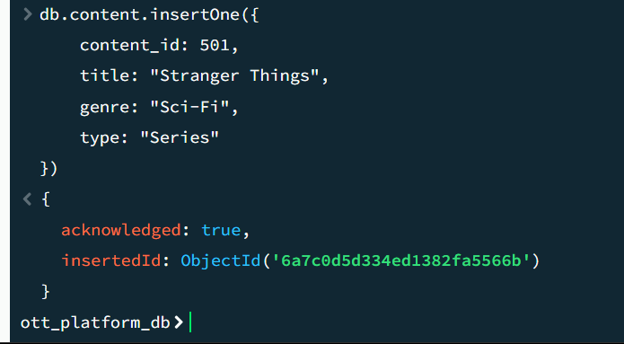
The insertOne() operation was used to insert a single document into the content collection. The document contains details such as content_id, title, genre, and type. The acknowledged: true output confirms that the document was successfully inserted.
Insert many
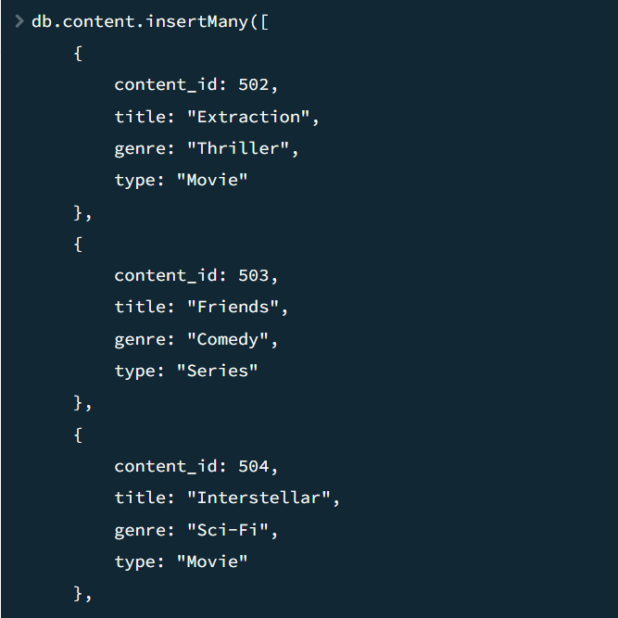
The insertMany() operation was used to insert multiple OTT content documents into the content collection at once. This reduces the need to execute separate insertion commands for each document. The successful acknowledgement confirms that the documents were inserted successfully.

READ OPERATIONS
find() — Display all content
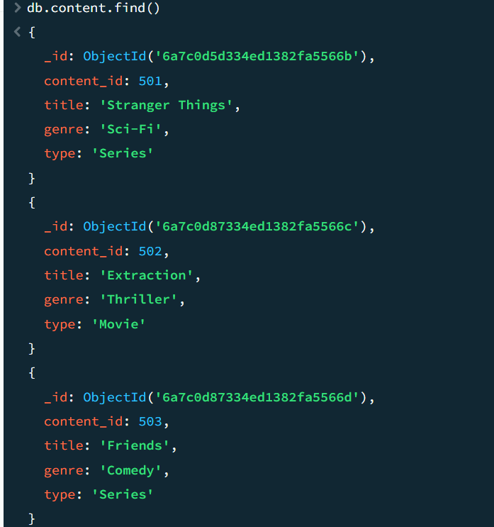
The find() operation was used to retrieve all documents from the content collection. It displays the complete set of OTT content records stored in the collection.
findOne() — Find one content
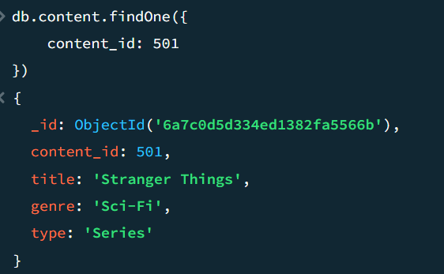
The findOne() operation was used to retrieve a single document matching the specified content_id. It returns only the first matching document, which allows a particular OTT content record to be viewed.
find() with a filter
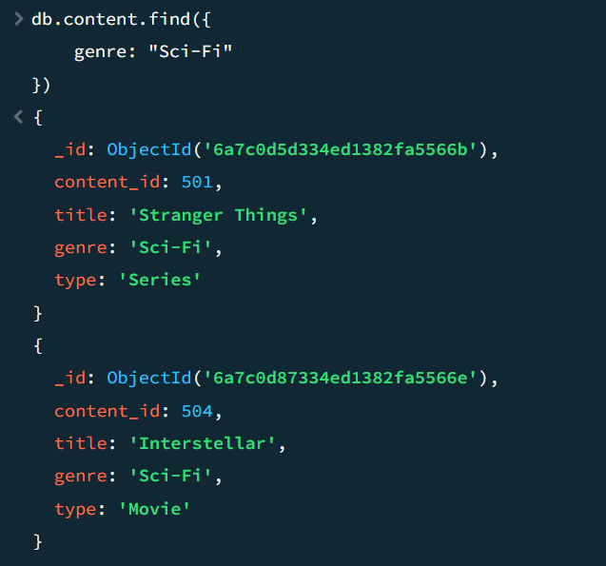
A filter was applied with find() to retrieve only the documents satisfying a specified condition. In this example, the query retrieves OTT content belonging to the Sci-Fi genre.
Another filter — Movies only
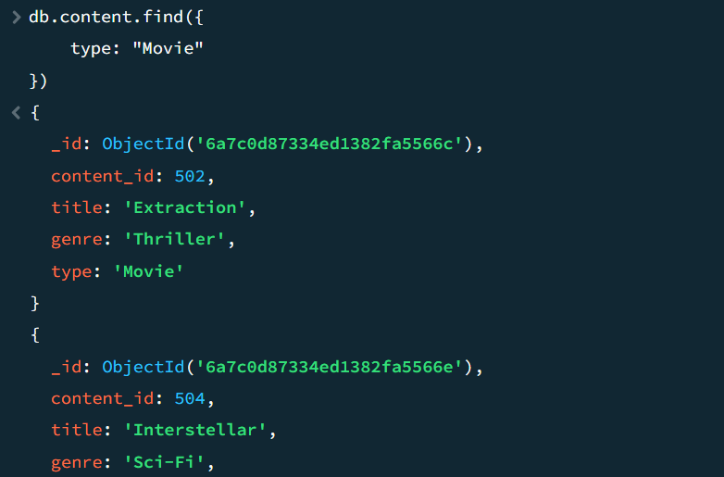
A filter was applied to the type field to retrieve only OTT content classified as Movie. This demonstrates how MongoDB can selectively retrieve documents based on field values.
Filter with selected fields
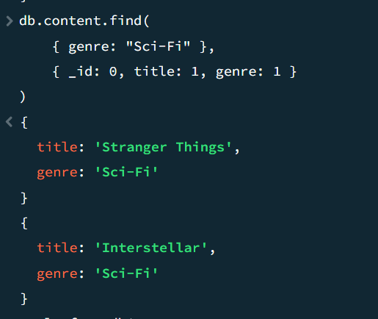
A projection was used along with the filter to display only the required fields, such as the content title and genre. The _id field was excluded to make the output more readable.
LOGICAL OPERATORS
$and
We will find subscriptions where:
- status is Active
- AND plan ID is greater than or equal to 202
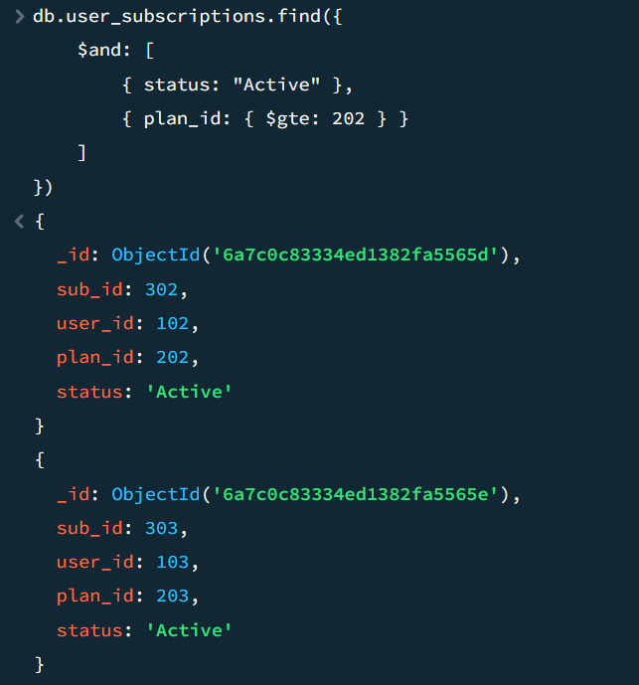
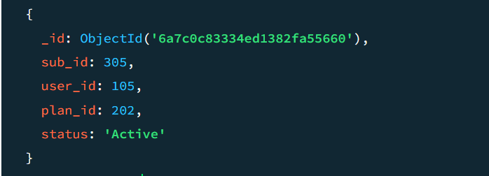
The $and operator was used to retrieve subscriptions satisfying both conditions: the subscription status must be Active and the plan_id must be greater than or equal to 202. Only documents satisfying both conditions are returned.

$or
Find users whose name is Anugrahaa OR Priya.
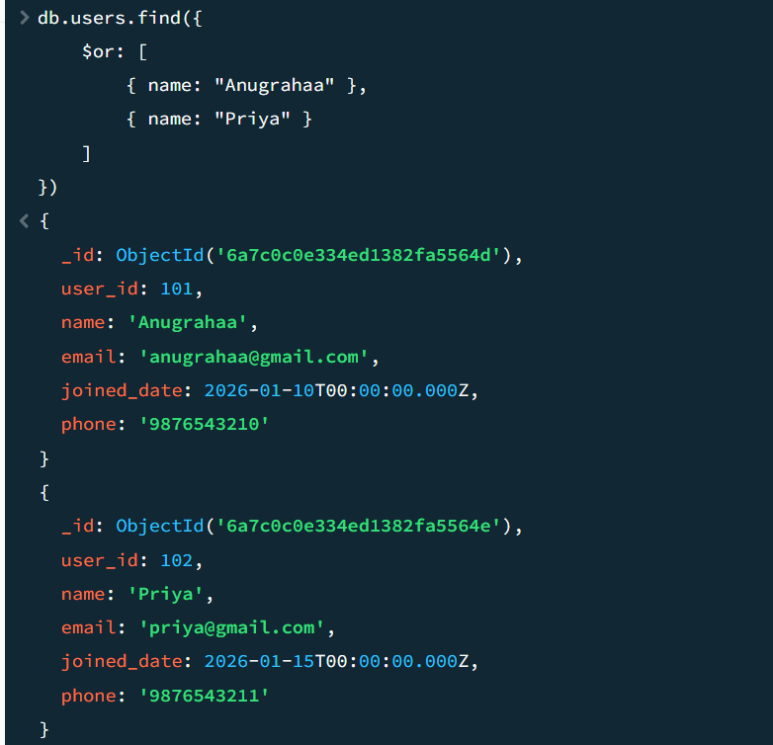
The $or operator was used to retrieve users whose name is either Anugrahaa or Priya. A document is returned when at least one of the specified conditions is satisfied.
$not
Now we'll use your subscription plan prices.
Find plans where the price is NOT greater than 400.
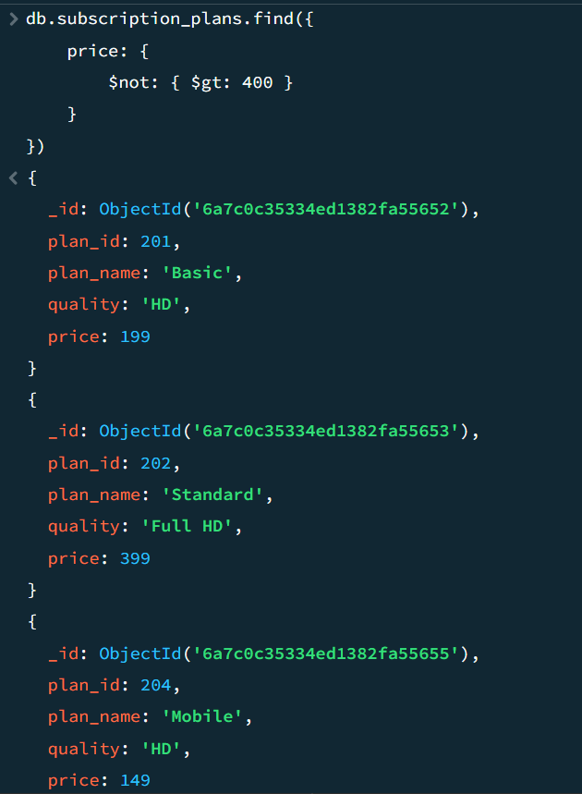
The $not operator was used to reverse the specified condition. Here, it retrieves subscription plans whose price is not greater than ₹400.
$nor
Now find subscriptions that are:
- NOT Expired
- AND NOT using Plan 203
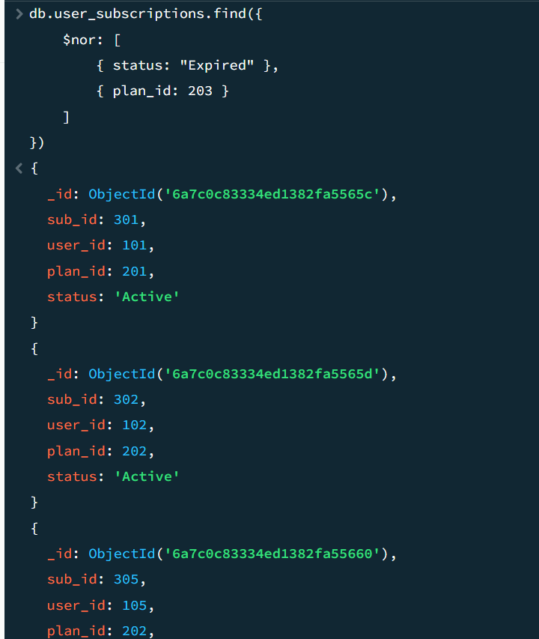
The $nor operator was used to retrieve subscriptions that satisfy neither of the specified conditions. In this example, subscriptions that are Expired or use Plan 203 are excluded from the result.
RELATIONAL OPERATORS
$gt — Greater Than
Find plans with price greater than ₹300.
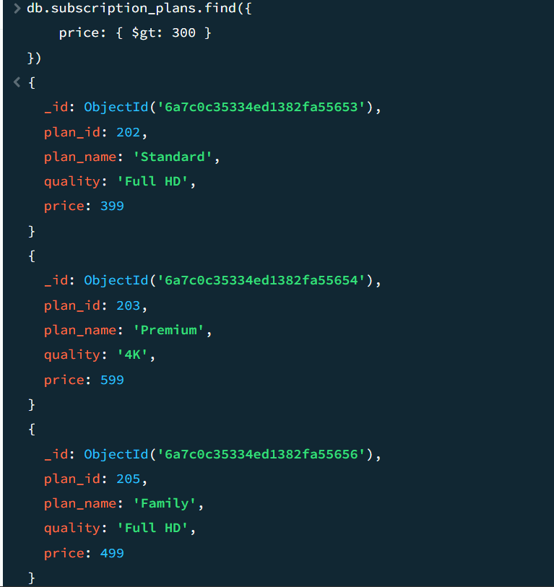
The $gt operator retrieves subscription plans whose price is greater than ₹300.
$lt — Less Than
Find plans with price less than ₹300.
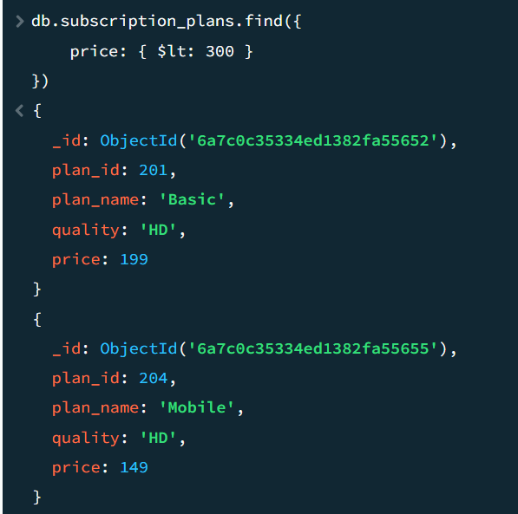
The $lt operator retrieves subscription plans whose price is less than ₹300.
$eq — Equal To
Find the plan whose price is exactly ₹399
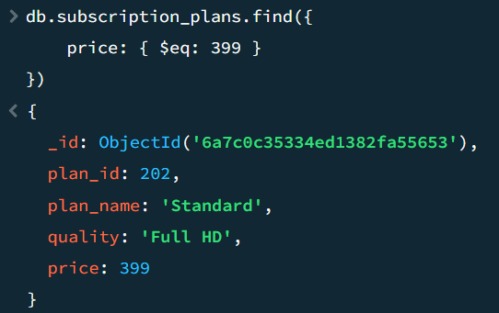
The $eq operator retrieves the subscription plan whose price is exactly ₹399.
$ne — Not Equal To
Find plans whose price is not ₹399.
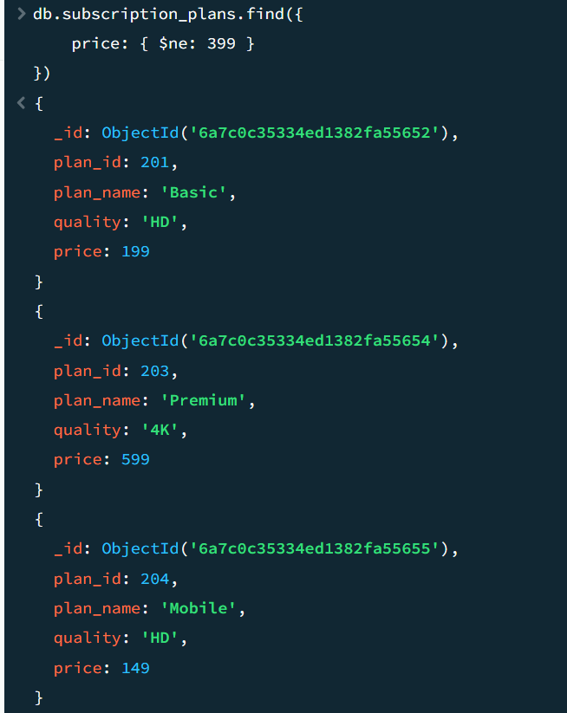
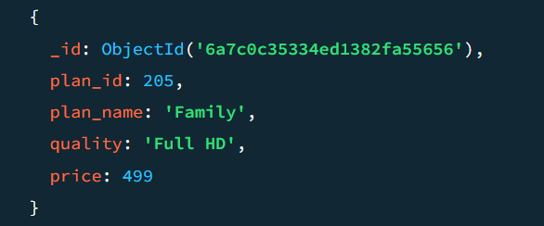
The $ne operator retrieves subscription plans whose price is not equal to ₹399.
$gte — Greater Than or Equal To
Find plans costing ₹399 or more.
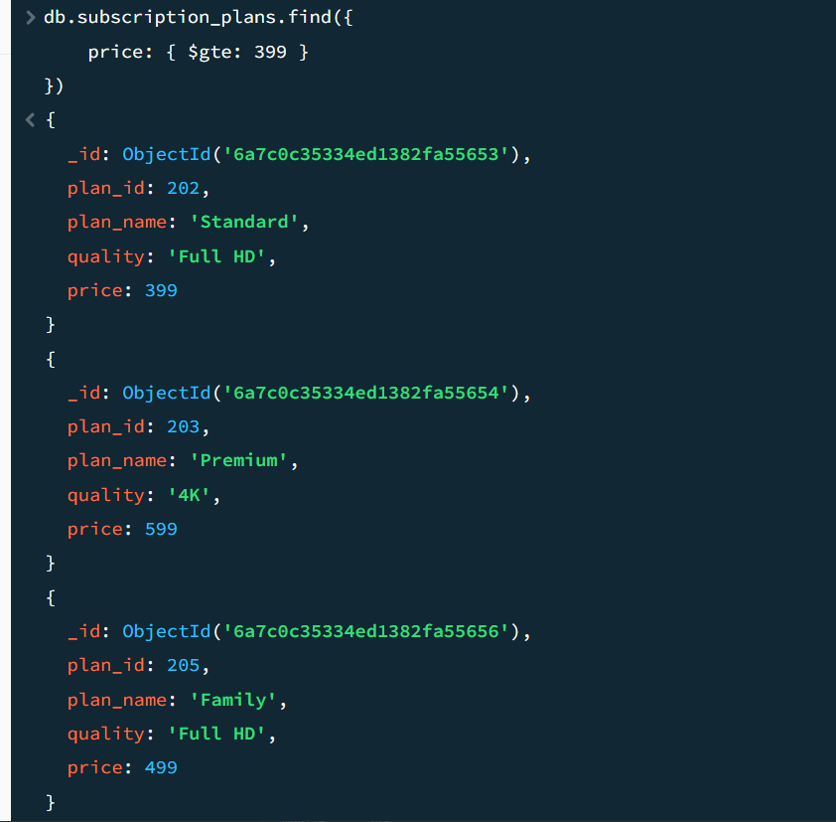
The $gte operator retrieves plans whose price is greater than or equal to ₹399.
$lte — Less Than or Equal To
Find plans costing ₹399 or less.
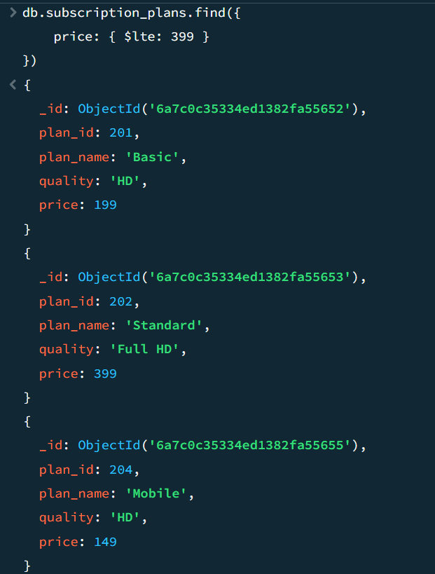
The $lte operator retrieves plans whose price is less than or equal to ₹399.
$in — Match Any Value in a List
Find plans whose price is either ₹199 or ₹599.
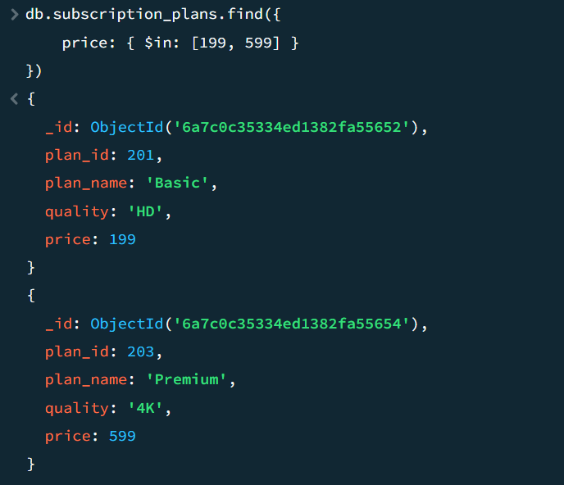
The $in operator retrieves plans whose price matches any of the specified values. In this example, plans priced at ₹199 or ₹599 are retrieved.
$nin — Not in a List
Find plans whose price is neither ₹199 nor ₹599.
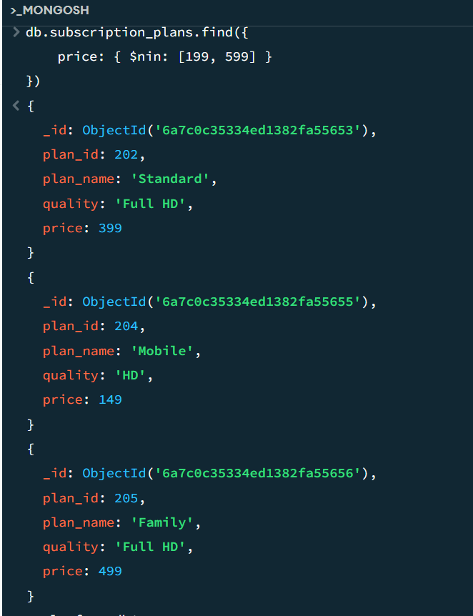
The $nin operator retrieves plans whose price does not match any of the specified values. Therefore, plans priced at ₹199 and ₹599 are excluded.
UPDATE OPERATIONS
updateOne()
Let's update Anugrahaa's email address in the users collection.
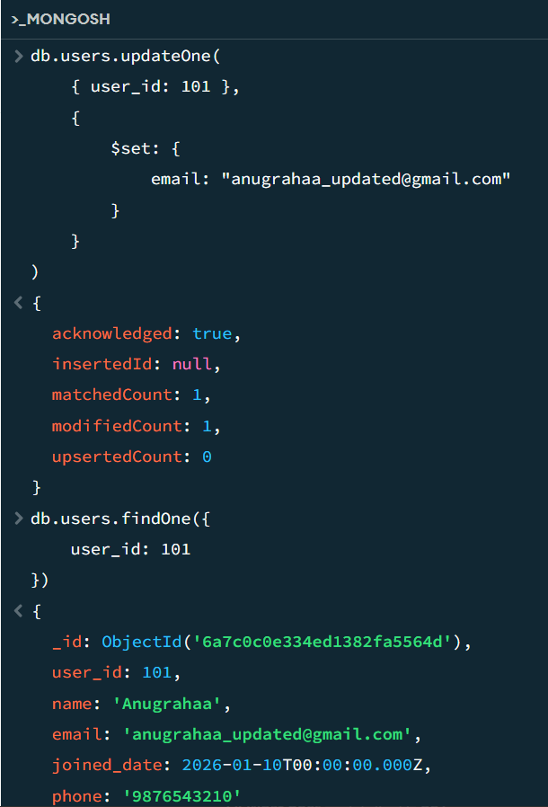
The updateOne() operation was used to modify the email address of the user with user_id 101. The $set operator updates only the specified field without changing the other fields in the document.
updateMany()
Now we'll update multiple documents.
Let's add an auto_renew field to all Active subscriptions.
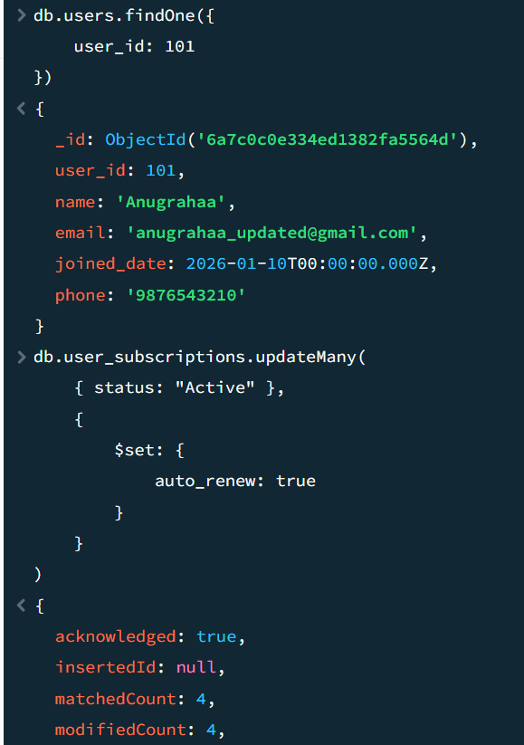
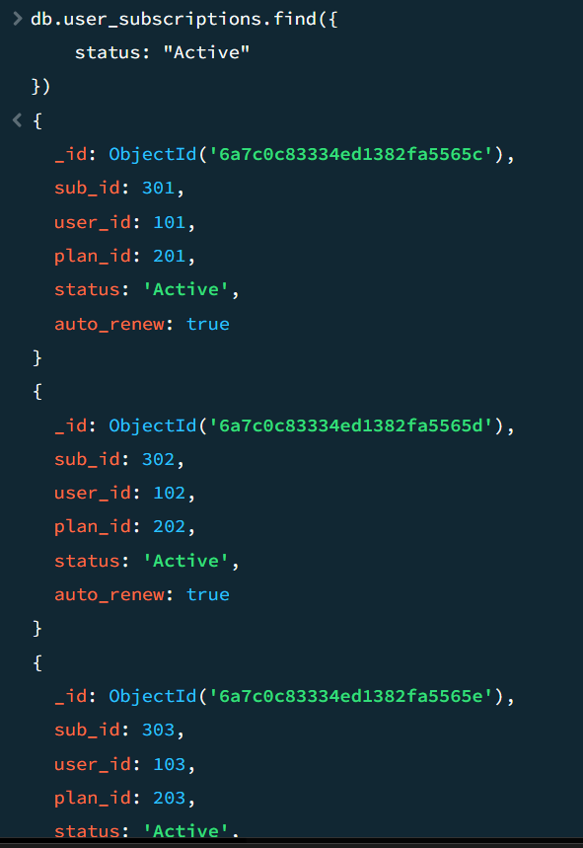
The updateMany() operation was used to add the auto_renew field to all active subscriptions. Since multiple documents satisfy the condition status: "Active", all matching documents are updated.
Update a nested value
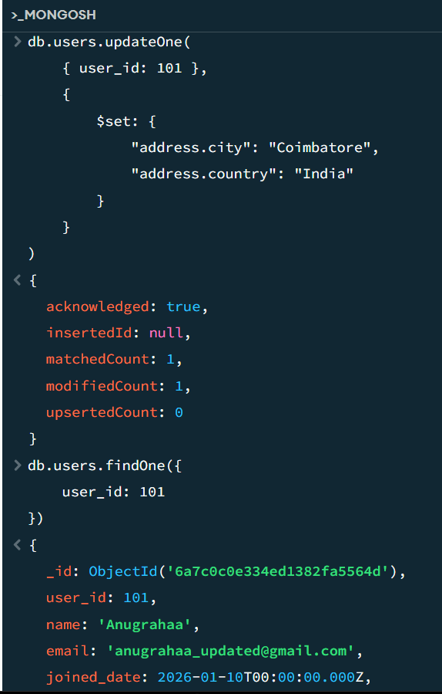
A nested field was updated using MongoDB dot notation. The $set operator was used to add or modify values such as the user's city and country inside the address object.
DELETE OPERATIONS
deleteOne()
We'll add one temporary OTT content record with a unique content_id.
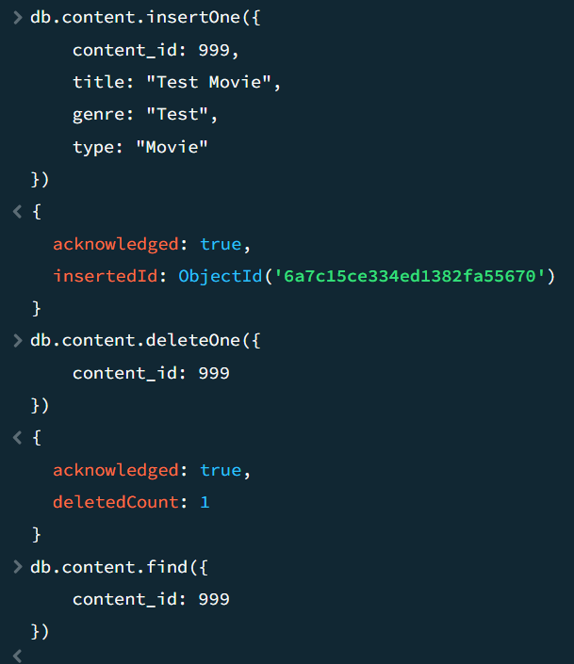
The deleteOne() operation was used to remove one temporary OTT content document identified by its unique content_id. The deletedCount: 1 result confirms that exactly one document was deleted.
deleteMany()
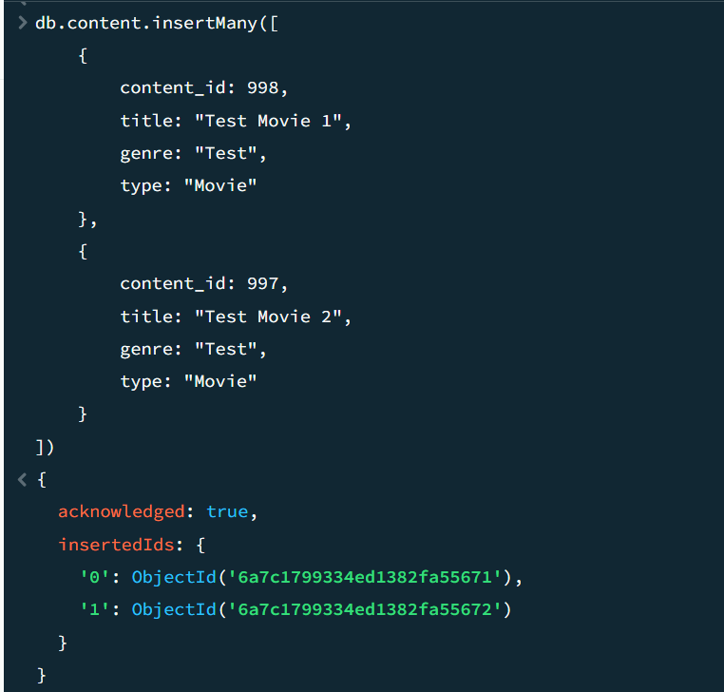

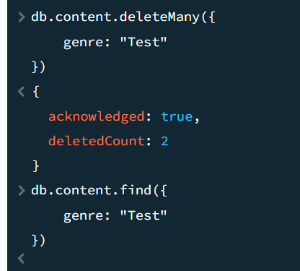
The deleteMany() operation was used to remove multiple temporary documents that matched the specified condition. The deletedCount value indicates the number of documents successfully removed.
AGGREGATION
$match
$match filters documents before the next aggregation stage.
Let's find only Active subscriptions.
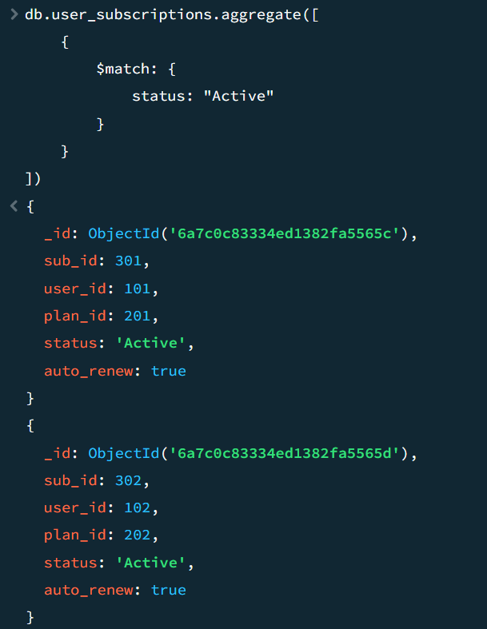
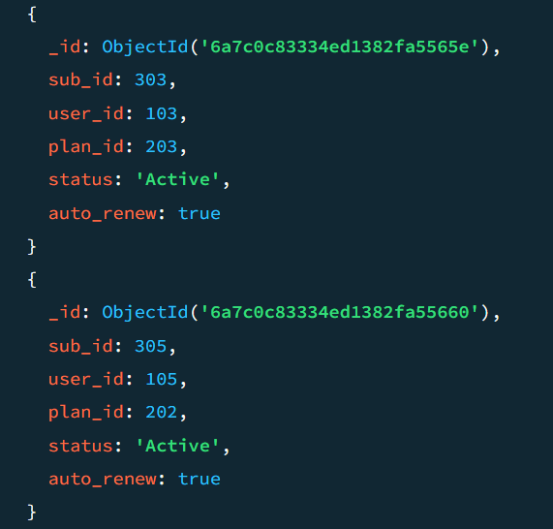
The $match stage filters documents in the aggregation pipeline. Here, it is used to retrieve only subscriptions with an Active status.
$group
Let's group your subscriptions based on plan_id
$group groups documents that have the same value in a specified field.
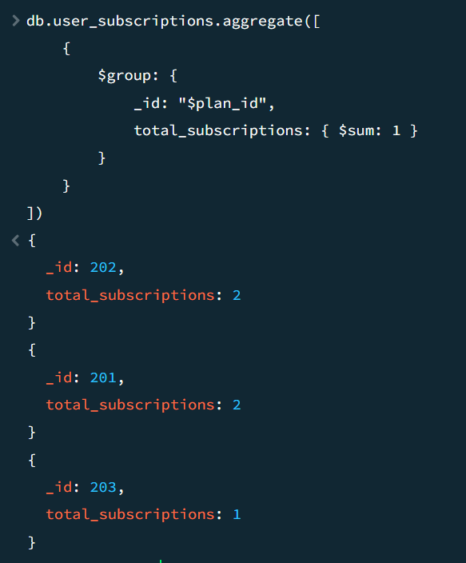
The $group stage groups documents according to a specified field. Here, subscriptions are grouped based on plan_id and the number of subscriptions in each plan is calculated.
$sum
calculate the total payment amount.
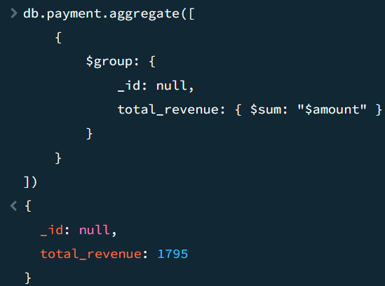
The $sum accumulator was used to calculate the total payment amount from all payment records. It adds the values stored in the amount field.
$avg
Find the average payment amount.
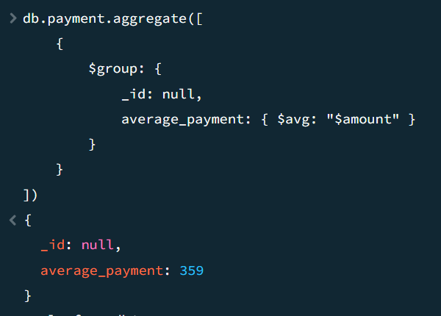
The $avg accumulator was used to calculate the average payment amount. It computes the mean of the values stored in the amount field.
$count
Count the number of users.
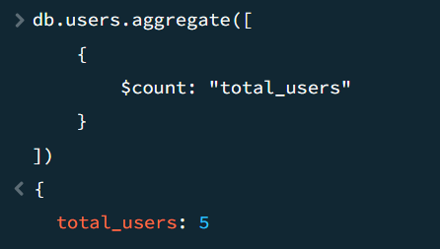
The $count stage was used to count the number of documents in the collection. In this example, it is used to determine the total number of users.

$project
Let's display only the content title and genre.
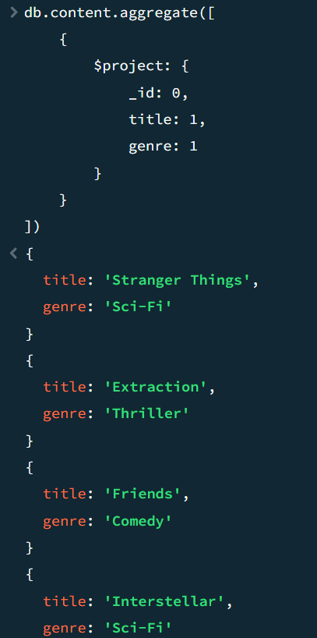
The $project stage was used to control which fields appear in the aggregation output. Here, only the content title and genre are displayed.
$sort
Let's sort subscription plans by price from highest to lowest.
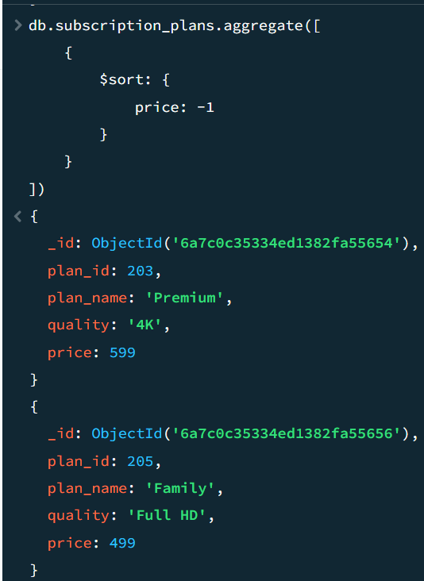
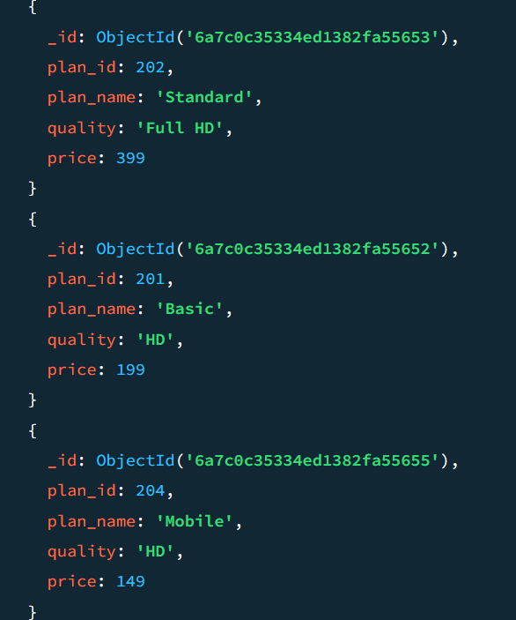
The $sort stage was used to arrange subscription plans according to their price. A value of -1 sorts the documents in descending order, from the highest price to the lowest.

$unwind
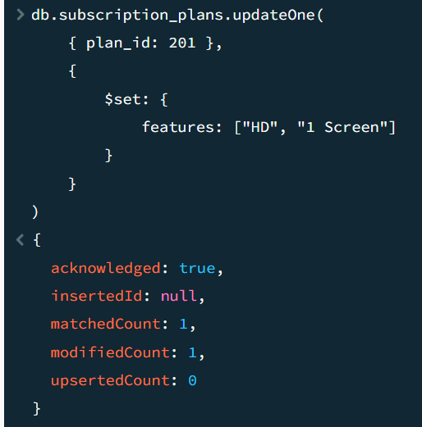
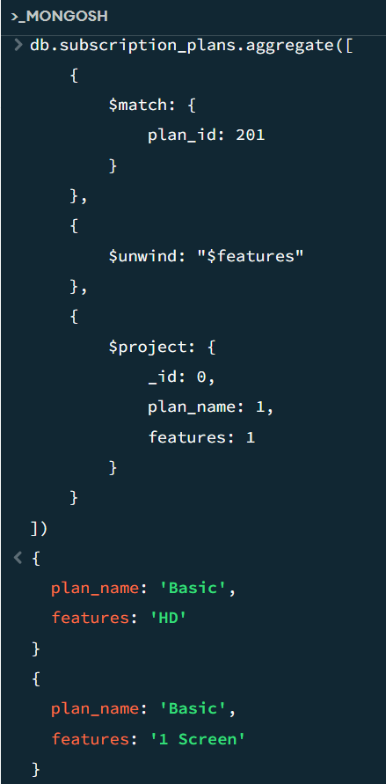
The $unwind stage was used on the features array to create a separate output document for each element in the array. This demonstrates how MongoDB can expand array elements during aggregation.
$lookup
We'll connect:
user_subscriptions
↓
Users
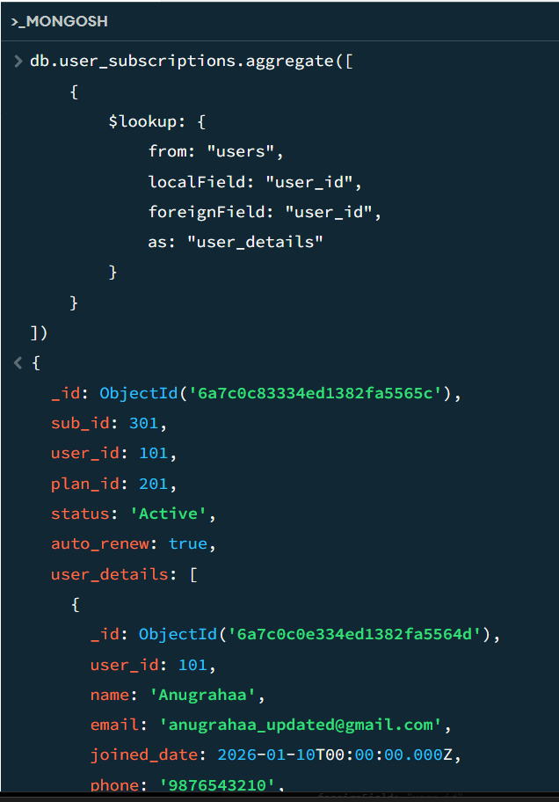
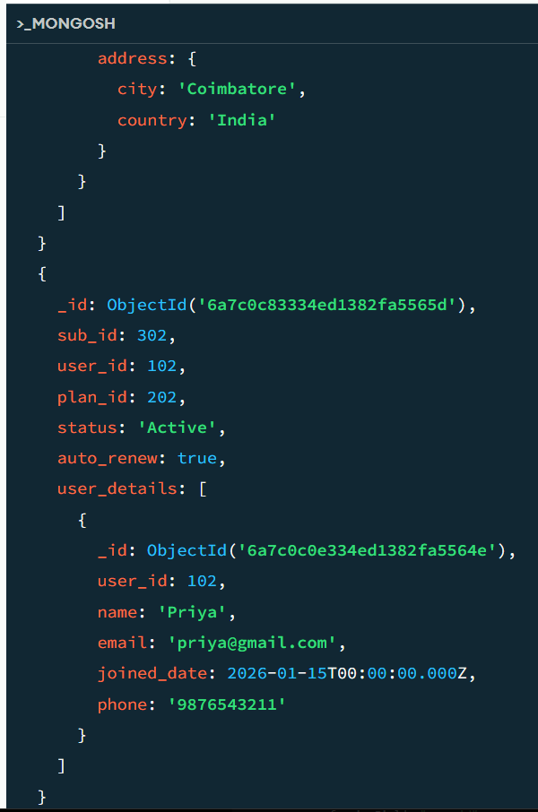
The $lookup stage was used to combine data from the user_subscriptions and users collections using the common user_id field. It works similar to a left outer join in a relational database and allows subscription information to be displayed together with user details.

